Abstract title

A. B. Author1, C. D. Presentingauthor2, E. Viceauthor2, F. Alsoauthor1 and G. H. Lastauthor1

1Institute for Dynamical Studies and Solid Properties, Anytown, Anyland

2Another Institute for Other Studies, Elsewhere

[corresponding_author@email.address](mailto:corresponding_author@mail.address)

We would like to ask you to submit your abstract as a single A4 page Word document **by overwriting this template**. Overwriting this document instead of starting a new one will preserve all the styles necessary for automated document processing. If you copy & paste text portions from another document, please use strictly the **Keep Text Only** paste option (by right-clicking in your Word document, open the local menu and choose Keep Text Only from the Paste Options).

The abstract should be typed in English. The presenting author should be underlined. If you provide references, please keep **exactly** the format provided [1, 2], including separation of the author initials and surnames by a nonbreaking space (Ctrl + Shift + Space).

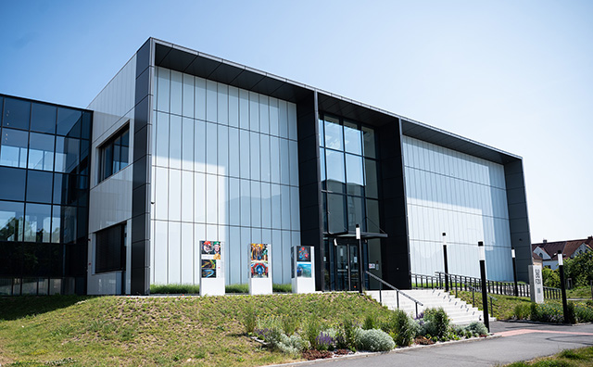

Fig. 1: The conference venue - SOLID21 building of the Institute of Physics of the Czech Academy of Sciences.

The whole text is typed in Times New Roman. The title is in 16 pt bold, author names in 13 pt normal, affiliations and e-mail contact in 11 pt italics, all centered. The body is in 13 pt normal, justified. Acknowledgements and References are in 10 pt normal. Avoid using condensed character spacing.

The text may also contain small tables or figures.

The abstracts should be submitted through our web-based upload form.

Acknowledgements: The conference organizers will highly appreciate your submission.

[1] A. Author, B. Author, C. Author and D. Author, *Journal Title* **17**, 1234 (2018).

[2] A. Author and B. Author, *Book Title*, pp. 10–75, Publisher (2018).